After Installing XAMPP configure using XAMPP control panel

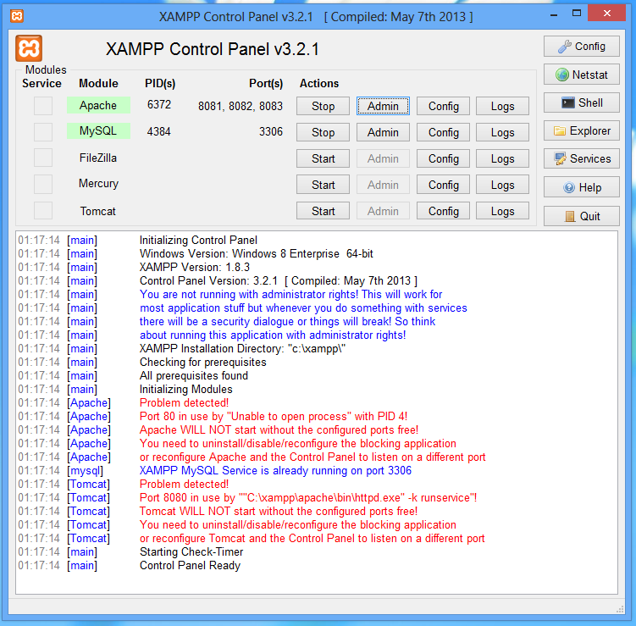

If you have IIS running then you will have some problems due to port 80 already used by IIS and you may need to tweak XAMPP config for another port.

For example http to port 8080, 8081… and ssl to4499 from 443 (always good idea to back up the conf file)

Create a membership registration using PHP/MySQL

Step 1: Create your database schema on MySQL:

CREATE SCHEMA `Membership` ;

Step 2: Normalised relational database

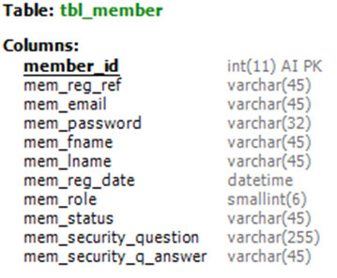

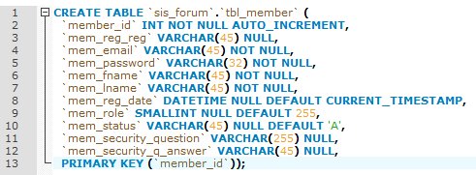

CREATE TABLE `tbl_member` (

`member_id` INT NOT NULL AUTO_INCREMENT,

`mem_reg_ref` VARCHAR(45) NULL,

`mem_email` VARCHAR(45) NOT NULL,

`mem_password` VARCHAR(45) NOT NULL,

`mem_fname` VARCHAR(45) NOT NULL,

`mem_lname` VARCHAR(45) NOT NULL,

`mem_reg_date` DATETIME NULL DEFAULT CURRENT_TIMESTAMP,

`mem_role` SMALLINT NULL DEFAULT 255,

`mem_status` VARCHAR(45) NULL DEFAULT 'A',

`mem_security_question` VARCHAR(255) NULL,

`mem_security_q_answer` VARCHAR(45) NULL,

PRIMARY KEY (`member_id`));

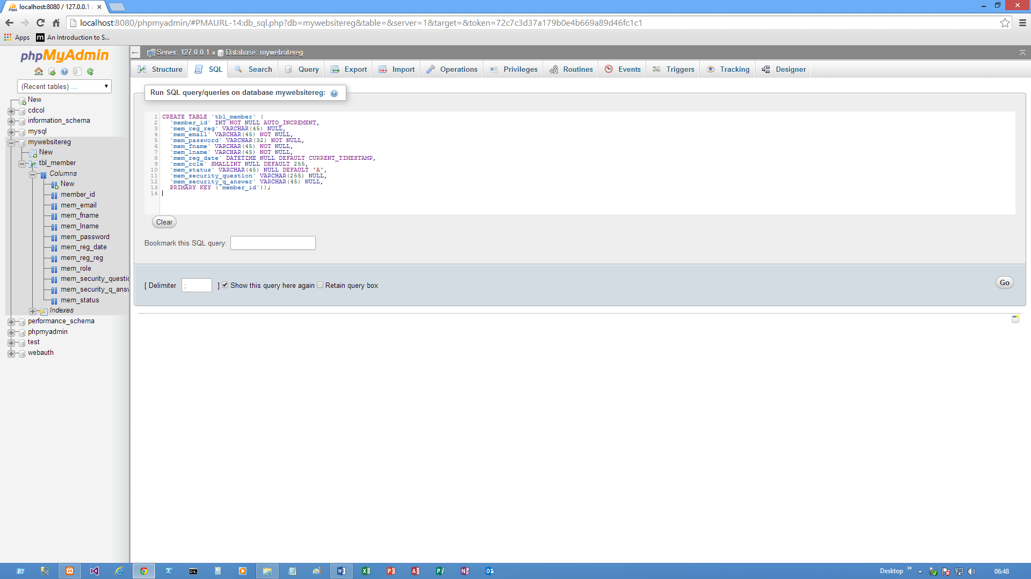

**Front-end Development**

**Create the relevant pages:**

**Header file**: header.php

**Main content**: [mypage].php

**Footer file**: footer.php

**Connection details**: connect.php

**NOTE**: All password should be encrypted using the function **sha1()** or **md5()**; hackers could get access to your plain-text password!

**Step 1: Connection file – connection details – connect.php**

**Note when working with database:**

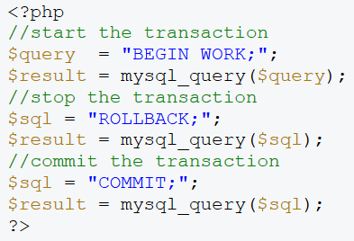see later example in PHP files

**Step 2: Create Header and footer PHP file to include in all PHP files**

<!DOCTYPE html>

<html>

<head>

<meta http-equiv="Content-Type" content="text/html; charset=UTF-8" />

<meta name="description" content="A short description." />

<meta name="keywords" content="put, keywords, here" />

<title>Membership using PHP-MySQL</title>

<link rel="stylesheet" href="style.css" type="text/css">

</head>

<body>

<h1>My Membership</h1>

<div id="wrapper">

<div id="menu">

<a class="item" href="/forum/index.php">Home</a> -

<a class="item" href="/forum/create_topic.php">Create a topic</a> -

<a class="item" href="/forum/create_cat.php">Create a category</a>

<div id="userbar">

<?php

<div id="userbar">

if($_SESSION['signed_in'])

{

echo 'Hello' . $_SESSION['user_name'] . '. Not you? <a href="signout.php">Sign out</a>';

}

else

{

echo '<a href="signin.php">Sign in</a> or <a href="sign up">create an account</a>.';

}

</div>

</div>

<div id="content">

--------------------------------------------------------------------------------------

</div><!-- content -->

</div><!-- wrapper -->

<div id="footer">SISE Limited

</div>

</body>

</html>

------------------------------------------------------------------------------------------

body {

background-color: #4E4E4E;

text-align: center; /* make sure IE centers the page too */

}

#wrapper {

width: 900px;

margin: 0 auto; /* center the page */

}

#content {

background-color: #fff;

border: 1px solid #000;

float: left;

font-family: Arial;

padding: 20px 30px;

text-align: left;

width: 100%; /* fill up the entire div */

}

#menu {

float: left;

border: 1px solid #000;

border-bottom: none; /* avoid a double border */

clear: both; /* clear:both makes sure the content div doesn't float next to this one but stays under it */

width:100%;

height:30px;

padding: 0 30px;

background-color: #FFF;

text-align: left;

font-size: 85%;

}

#menu a:hover {

background-color: #009FC1;

}

#userbar {

background-color: #fff;

float: right;

width: 250px;

}

#footer {

clear: both;

}

/* begin table styles */

table {

border-collapse: collapse;

width: 100%;

}

table a {

color: #000;

}

table a:hover {

color:#373737;

text-decoration: none;

}

th {

background-color: #B40E1F;

color: #F0F0F0;

}

td {

padding: 5px;

}

/* Begin font styles */

h1, #footer {

font-family: Arial;

color: #F1F3F1;

}

h3 {margin: 0; padding: 0;}

/* Menu styles */

.item {

background-color: #00728B;

border: 1px solid #032472;

color: #FFF;

font-family: Arial;

padding: 3px;

text-decoration: none;

}

.leftpart {

width: 70%;

}

.rightpart {

width: 30%;

}

.small {

font-size: 75%;

color: #373737;

}

#footer {

font-size: 65%;

padding: 3px 0 0 0;

}

.topic-post {

height: 100px;

overflow: auto;

}

.post-content {

padding: 30px;

}

textarea {

width: 500px;

height: 200px;

}

---------------------------------------------------------------------------------------------

<?php

//signin.php

include 'connect.php';

include 'header.php';

echo '<h3>Sign in</h3>';

//first, check if the user is already signed in. If that is the case, there is no need to display this page

if (isset($_SESSION['signed_in']) && $_SESSION['signed_in'] == true)

{

echo 'You are already signed in, you can <a href="signout.php">sign out</a> if you want.';

}

else

{

if($_SERVER['REQUEST_METHOD'] != 'POST')

{

/*the form hasn't been posted yet, display it

note that the action="" will cause the form to post to the same page it is on */

echo '<form method="post" action="">

Username (Registration Ref): <input type="text" name="mem_reg_ref" />

Password: <input type="password" name="mem_password">

<input type="submit" value="Sign in" />

</form>';

}

else

{

/* so, the form has been posted, we'll process the data in three steps:

1. Check the data

2. Let the user refill the wrong fields (if necessary)

3. Varify if the data is correct and return the correct response

*/

$errors = array(); /* declare the array for later use */

if(!isset($_POST['mem_reg_ref']))

{

$errors[] = 'The username (Registration Ref) field must not be empty.';

}

if(!isset($_POST['mem_password']))

{

$errors[] = 'The password field must not be empty.';

}

if(!empty($errors)) /*check for an empty array, if there are errors, they're in this array (note the ! operator)*/

{

echo 'Uh-oh.. a couple of fields are not filled in correctly..';

echo '<ul>';

foreach($errors as $key => $value) /* walk through the array so all the errors get displayed */

{

echo '<li>' . $value . '</li>'; /* this generates a nice error list */

}

echo '</ul>';

}

else

{

//the form has been posted without errors, so save it

//notice the use of mysql_real_escape_string, keep everything safe!

//also notice the sha1 function which hashes the password

//mem_password = '" . sha1($_POST['mem_password']) . "'";

$sql = "SELECT

member_id,

mem_reg_ref,

mem_fname,

mem_role

FROM

tbl_member

WHERE

mem_reg_ref = '" . mysql_real_escape_string($_POST['mem_reg_ref']) . "'

AND

mem_password = '" . sha1($_POST['mem_password']) . "'";

$result = mysqli_query($_SESSION['Cn'],$sql);

if(!$result)

{

//something went wrong, display the error

echo 'Something went wrong while signing in. Please try again later.';

//echo mysql_error(); //debugging purposes, uncomment when needed

}

else

{

//the query was successfully executed, there are 2 possibilities

//1. the query returned data, the user can be signed in

//2. the query returned an empty result set, the credentials were wrong

if(mysqli_affected_rows($_SESSION['Cn'])== 0)

{

echo 'You have supplied a wrong membership/password combination. Please try again.';

}

else

{

//set the $_SESSION['signed_in'] variable to TRUE so that we can use it in other pages

$_SESSION['signed_in'] = true;

//we also put the user_id and user_name values in the $_SESSION, so we can use it at various pages

while($row = mysqli_fetch_assoc($result))

{

$_SESSION['member_id'] = $row['member_id'];

$_SESSION['mem_reg_ref'] = $row['mem_reg_ref'];

$_SESSION['mem_fname'] = $row['mem_fname'];

$_SESSION['mem_role'] = $row['mem_role'];

}

echo 'Welcome, ' . $_SESSION['mem_fname'] . '. <a href="index.php">Proceed to the forum overview</a>.';

}

}

}

}

}

include 'footer.php';

?>

---------------------------------------------------------------------------------

<?php

//signup.php

include 'connect.php';

include 'header.php';

echo '<h3>Sign up</h3>';

if($_SERVER['REQUEST_METHOD'] != 'POST')

{

/*the form hasn't been posted yet, display it

note that the action="" will cause the form to post to the same page it is on */

echo '<form method="post" action="">

Username (Registraion Ref): <input type="text" name="mem_reg_ref" />

<br>Firstname: <input type="text" name="mem_fname" />

<br>Lastname: <input type="text" name="mem_lname" />

<br>Password: <input type="password" name="mem_password">

<br>Password again: <input type="password" name="mem_password_check">

<br>E-mail: <input type="email" name="mem_email">

<br>Security Question: <input type="text" name="mem_security_question">

<br>Answer: <input type="text" name="mem_security_Q_answer">

<br><input type="submit" value="Create user account" />

</form>';

}

else

{

/* so, the form has been posted, we'll process the data in three steps:

1. Check the data

2. Let the user refill the wrong fields (if necessary)

3. Save the data

*/

$errors = array(); // declare the array for later use

if(isset($_POST['mem_reg_ref']))

{

//the user name exists

if(!ctype_alnum($_POST['mem_reg_ref']))

{

$errors[] = 'The username/registration Ref can only contain letters and digits.';

}

if(strlen($_POST['mem_reg_ref']) > 30)

{

$errors[] = 'The username/registration Ref cannot be longer than 30 characters.';

}

}

else

{

$errors[] = 'The username field must not be empty.';

}

if(isset($_POST['mem_password']))

{

if($_POST['mem_password'] != $_POST['mem_password_check'])

{

$errors[] = 'The two passwords did not match.';

}

}

else

{

$errors[] = 'The password field cannot be empty.';

}

if(!empty($errors)) //check for an empty array, if there are errors, they're in this array (note the ! operator)

{

echo 'Uh-oh.. a couple of fields are not filled in correctly..';

echo '<ul>';

foreach($errors as $key => $value) // walk through the array so all the errors get displayed

{

echo '<li>' . $value . '</li>'; // this generates a nice error list

}

echo '</ul>';

}

else

{

//the form has been posted without, so save it

//notice the use of mysql_real_escape_string, keep everything safe!

//also notice the sha1 function which hashes the password

$sql = "INSERT INTO

tbl_member(mem_reg_ref, mem_fname, mem_lname, mem_password, mem_email,

mem_security_question, mem_security_Q_answer, mem_reg_date, mem_role)

VALUES('" . mysql_real_escape_string($_POST['mem_reg_ref']) . "',

'" . mysql_real_escape_string($_POST['mem_fname']) . "',

'" . mysql_real_escape_string($_POST['mem_lname']) . "',

'" . sha1($_POST['mem_password']) . "',

'" . mysql_real_escape_string($_POST['mem_email']) . "',

'" . mysql_real_escape_string($_POST['mem_security_question']) . "',

'" . mysql_real_escape_string($_POST['mem_security_Q_answer']) . "',

NOW(),

255)";

$result = mysqli_query($_SESSION['Cn'],$sql);

if(!$result)

{

//something went wrong, display the error

echo 'Something went wrong while registering. Please try again later.';

//echo mysql_error(); //debugging purposes, uncomment when needed

}

else

{

echo 'Successfully registered. You can now <a href="signin.php">sign in</a> and start posting! :-)';

}

}

}

include 'footer.php';

?>